…This represents **Part 2** of a **4-part series** relative to the calculation of **Equity Cash Flow** (**ECF**) using **R**. If you missed **Part 1**, be certain read that first part before proceeding. The content builds off prior described information/data. **‘ECF – Method 2’** is defined as follows:

The equation appears innocent enough, though there are many underlying terms that require definition for understanding of the calculation. In words, ‘**ECF – Method 2’** equals free cash Flow (**FCFF**) minus after-tax Debt Cash Flow (**CFd**).

Reference details of the **5-year capital project’s fully integrated financial statements developed in R** at the following link. The R output is formatted in Excel. Zoom for detail.

The first order of business is to define the terms necessary to calculate **FCFF.**

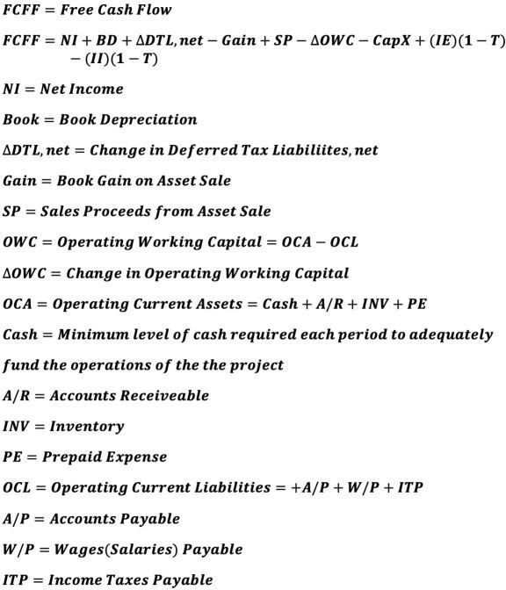

Next, pretax Debt Cash Flow (CFd) and its components are defined as follows:

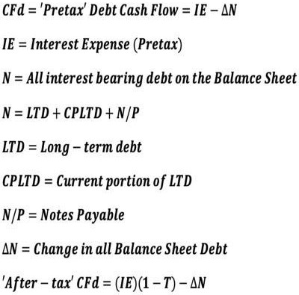

The following data are added to the ‘**data**’ tibble from the prior article relative to the financial statements.

data <- data %>%

mutate(ie = c(0, 10694, 8158, 527, 627, 717 ),

np = c(31415, 9188, 13875, 16500, 18863, 0),

LTD = c(250000, 184952, 0, 0, 0, 0),

cpltd = c(0, 20550, 0, 0, 0, 0),

ni = c(0, 47584, 141355, 262035, 325894, 511852),

bd = c(0, 62500, 62500, 62500, 62500, 62500),

chg_DTL_net = c(0, 35000, 55000, 35000, -25000, -100000),

|  |  |  |
| --- | --- | --- |
| cash | = | c(30500, 61250, 92500, 110000, 125750, 0), |
| ar | = | c(0, 61250, 92500, 110000, 125750, 0), |
| inv | = | c(30500, 61250, 92500, 110000, 125750, 0), |
| pe | = | c(915, 1838, 2775, 3300, 3773, 0), |
| ap | = | c(30500, 73500, 111000, 132000, 150900, 0), |
| wp | = | c(0, 5513, 8325, 9900, 11318, 0), |
| itp | = | c(0, -819.377, 9809, 34923, 60566, 0), |
| CapX | = | c(500000,0,0,0,0,0), |
| gain | = | c(0,0,0,0,0,162500), |

sp = c(0,0,0,0,0,350000))

# View tibble.

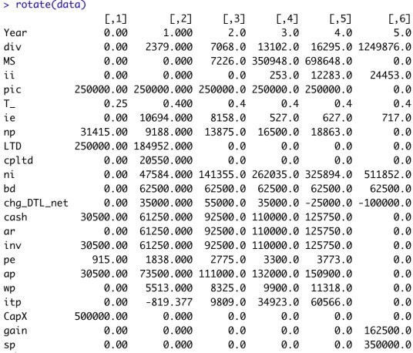

All of the above calculations are defined in the below **R** function **ECF_2**. **‘ECF – Method 2’ R function**

ECF_2 <- function(a) {

ECF2 <- tibble(T_ = a$T_,

ie = a$ie,

ii = a$ii,

Year = c(0:(length(ii)-1)), ni = a$ni,

bd = a$bd,

chg_DTL_net = a$chg_DTL_net, gain = - a$gain,

sp = a$sp,

ie_AT = ie*(1-a$T_), ii_AT = - ii*(1-a$T_),

gcf = ni + bd + chg_DTL_net + gain + sp

+ ie_AT + ii_AT,

OCA = a$cash + a$ar + a$inv + a$pe, OCL = a$ap + a$wp + a$itp,

OWC = OCA - OCL,

chg_OWC = OWC - lag(OWC, default=0), CapX = - a$CapX,

FCFF1 = gcf + CapX - chg_OWC, N = a$LTD + a$cpltd + a$np, chg_N = N - lag(N, default=0), CFd_AT = ie*(1-T_) - chg_N, ECF2 = FCFF1 - CFd_AT )

ECF2 <- rotate(ECF2)

return(ECF2)

}

# Run the R function and view the output.

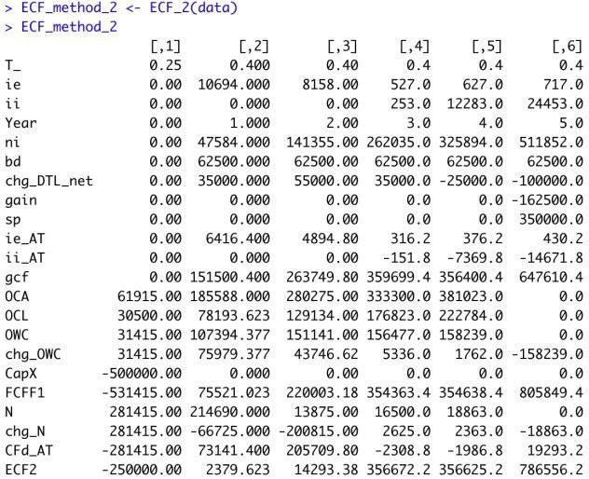

**R Output formatted in Excel Method 2**

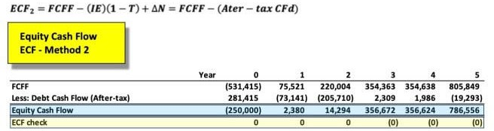

‘**ECF Method 2**‘ agrees with the prior results from ‘**ECF Method 1**‘ each year. Any differences are due to rounding error.

This **ECF** calculation example is taken from my newly published textbook, ‘**Advanced Discounted Cash Flow (DCF) Valuation using R**.’ It is discussed in far greater detail along with development of the integrated financials using **R** as well as numerous, advanced **DCF** valuation modeling approaches – some never before published. The text importantly clearly explains ‘**why’** these **ECF** calculation methods are **mathematically exactly equivalent**, though the individual components appear vastly different.

Reference my website for further details.